SHEPPEY MINIATURE ENGINEERING & MODEL SOCIETY

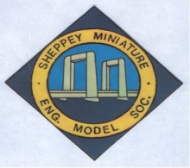

HOW IMLEC WORKS

The IMLEC competition is designed to test the efficiency of a model Locomotive and its driver’s ability to drive efficiently to obtain the maximum efficiency at that time.

In other words, how far can the loco go in 30 minutes pulling the heaviest load possible using the least amount of coal. The competitor obtaining the highest efficiency will be the winner.

There are two competition classes: - Class A -5-inch gauge locomotives and Class B 3½ -inch locomotives.

Prizes, kindly donated by Model Engineer and Workshop magazine will be

Class A
1st place £150

2nd place£100

3rd place £75

Clas B
1st place £75

In the event that a competitor in Class B is the overall winner, the Class B prize will be awarded to the second place

The runs are of 30 minutes and scheduled throughout the three days. 31/2 inch locomotives will normally run on Friday

